Title or Task: | Art How To Draw  

Description:

Files Required
Suitable for Classes: | Art
Area: | Technology & Enterprise
Teacher: | Mr Peter Faulks

Timeline

Date Due:

Task Brief:

Outcomes:

Items highlighted in yellow are tasks for you to complete
Items in Blue italics are help tips

ARTS

How To Draw

http://www.dragoart.com/
How to draw
http://entertainment.howstuffworks.com/how-to-draw-trains.htm

Title or Task: 1
Description: 1
Files Required 1
Suitable for Classes: 1
AIT • Multimedia • Cert II IT • Cert II Bus 1
Area: 1
Technology & Enterprise 1
Teacher: 1
Mr Peter Faulks 1
Timeline 1
Date Due: 1
Task Brief: 1
Outcomes: 1
Items highlighted in yellow are tasks for you to complete 1
ARTS 1
How To Draw 1
http://www.dragoart.com/ 1
How to Draw a Tropical Beach Scene 3
How to Draw a Rowboat at a Seawall 6
How to Draw a Harbour Scene 9
How to Draw Pirate Ships 12
How to Draw Sailboats 16
How to Draw a Country Church 19
How to Draw a Cityscape 23
How to draw a bulldozer. 28
How to Draw a Field of Flowers 34
How to Draw a Rural Lane 37
How to Draw a Mountain Stream 42
How to Draw a Mountain Vista 47
How to Draw an Icy Water Pump 50
How to Draw a Waterfall 54
How to Draw a Woodland Trail 59
How to Draw a Barn and Pond 64

Before you start drawing, there are some basic tools you need. Make sure you have a pencil, a pencil sharpener, an eraser, a felt-tip pen, and, of course, the grid paper where you'll make your drawings.

Throughout this article, the sketches start with larger basic shapes. Draw the full shape, even if all of it will not be seen in the final drawing. You can erase the part you don't need later.

Each consecutive step adds more detail until you have the finished drawing. The steps are collared to show exactly what to draw when: The drawings for each new step are shown with red lines, while the lines from previous steps are shown in gray.

After all the steps are drawn, use a felt-tip pen to trace the pencil lines. Go over only the lines you need in the final drawing. After giving the felt-tip ink some time to dry so it won't smear, use an eraser to erase the extra pencil lines.

Start off by using colouring tools that are familiar to you. For example, if you enjoy colouring with crayons, use them. When you get more comfortable with colouring, you can try other methods like collared pencils, watercolour paints, markers, or even collared chalk. Try different techniques on the drawings to see what looks best.

When you are ready to start colouring, pick colours that seem to fit the drawing best. Start by lightly adding the main colour to the drawing. Remember to keep the colours light at first -- it is much easier to make a colour darker than it is to make it lighter.

After the main colour is finished, gently add darker colours to areas on the boat that would be in shadows or less light. Adding colours this way is called shading, and it helps the drawing to look more realistic.

After shading the drawing, add lighter colours where more light would be. This is called highlighting, and it is usually done on the top areas of the shapes in the drawing. Think of sunlight coming down and lighting the boat from above.

Look at the colour pictures in the article and try to copy the light and dark shading of the colours. Once you fill in all the colours, your illustration is complete!

How to Draw a Tropical Beach Scene

The sun shines and palm trees sway in the breeze in this tropical beach scene. Learning to draw this landscape can be as relaxing as being in it.

In this section, we'll show you how to draw this tropical beach landscape. You can draw it freehand while looking at your computer monitor, or you can print out this page to get a closer look at each step.
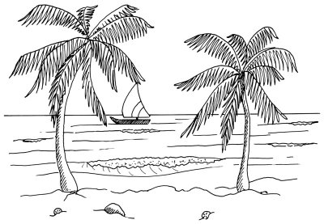

Here, we'll show you an illustration of each step and then give you a description of how to draw it. Follow the red lines in each illustration to learn exactly what to draw in that step. The lines drawn in previous steps are shown in gray.

To start drawing the tropical beach landscape, place a light horizon line in about the middle of the page.



Step 1: Place a light horizon line in about the middle of the page. Draw the hull of a sailboat with a long rectangle that has an upturned and sharply pointed end or bow. Make the sail using a triangle with two curved sides and a flat bottom. Draw a second, gently curving line below the boat to represent the shoreline.

To draw a tropical beach landscape, show waves near the shoreline with pairs of squiggly lines.

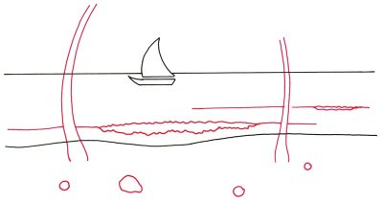
Step 2: Shape the trunks of palm trees with two sets of curving lines that taper as they go up. Sketch some rounded shapes on the sandy beach for coconuts and rocks. Show waves near the shoreline with pairs of squiggly lines. Extend each wave with single lines.

To draw a tropical beach landscape, add jagged lines near the trees and rocks to give contour to the beach.

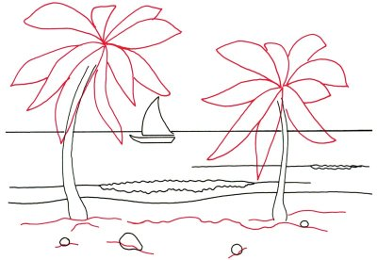
Step 3: Sketch in the basic outline for the large leaves at the tops of the palm trees. Add jagged lines near the trees and rocks to give contour to the beach.

To draw a tropical beach scene, use long, jagged lines to give form to the palm leaves.

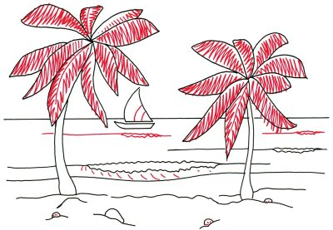
Step 4: Give form to the palm leaves with long, jagged lines, as shown. Use a pair of curved lines to make stripes on the boat's sail. Sketch a few more waves on the surface of the sea. Put in short lines on the front surface of the first wave. Add very short lines to the coconuts.

To complete your tropical beach drawing, add dots and squiggles to show the foam of a breaking wave.

Step 5: Use a series of diagonal parallel lines to shade one side of the tree trunks, the sailboat, and the rock. Complete the drawing with dots and squiggles to show the foam of a breaking wave. Add several lines to the surface of the water.

Your landscape drawing is finished! Even if you don't get it right the first time, keep practicing until you're happy with your drawing. A stone path leads to a charming country church in our next section. Keep reading to learn how to draw this scene in just five steps.

How to Draw a Rowboat at a Seawall

In this landscape scene, the sun shines on a rowboat tied to a seawall. This is a great landscape drawing for people who love the water and the shore.
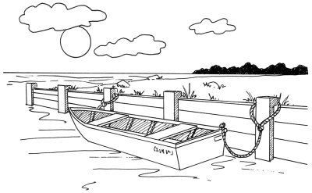

In this section, we'll show you how to draw this rowboat at a seawall landscape. You can draw it freehand while looking at your computer monitor, or you can print out this page to get a closer look at each step.

Here, we'll show you an illustration of each step and then give you a description of how to draw it. Follow the red lines in each illustration to learn exactly what to draw in that step. The lines drawn in previous steps are shown in gray.

To start drawing the rowboat at a seawall landscape, sketch a straight line to represent the horizon.

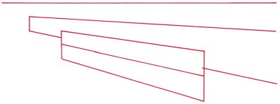
Step 1: Sketch a straight line to represent the horizon. Use your ruler to outline a long rectangle that widens and is open at the right end. To show the position of the rowboat, make a second, closed rectangle that overlaps the first. Draw a line through its centre.

To draw the rowboat at a seawall landscape, sketch an irregular line that meets the horizon for the shoreline.

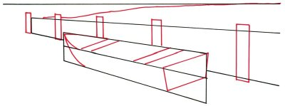
Step 2: Sketch an irregular line that meets the horizon on the right for the shoreline. With a ruler, place five tall, narrow rectangles next to the longer, horizontal rectangle, as shown. Make sure the tops and bottoms are in a straight line (check with a ruler).

Continue the rowboat by forming the bow or front end with three curved lines. Then arrange two seats with sets of parallel lines. Use a ruler to help get the lines to match. Draw another line parallel to the seats for the stern or rear end of the boat. Extend lines down from the ends of the last line and connect them to make another four-sided figure.

To draw the rowboat at a seawall landscape, sketch a few irregular shapes for clouds in the sky.

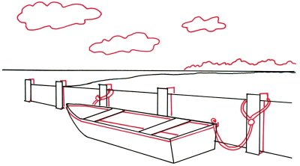
Step 3: Make an irregular, jagged line in the background, above the horizon line, to represent a mountain range. Add depth to the posts by using slanted rectangles at the sides and L-shaped lines at the top. Arrange two sets of curving, closely parallel lines for ropes to tie up the boat at both ends. Draw a few straight and curving lines to show the inside of the rowboat. Sketch a few irregular shapes for clouds in the sky.

To draw the rowboat at a seawall landscape, place a circular sun in the lower part of the sky.
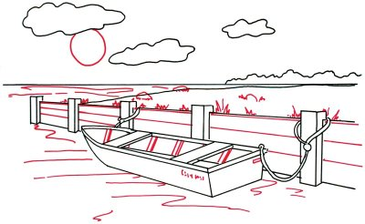
Step 4: Place a circular sun in the lower part of the sky. Suggest the surface of the water with curvy lines placed at random, both near the boat and in the distance. Put sets of diagonal lines inside the boat to show its riblike structure. Fill in a name of your choice on the side or back surface. Form the sea wall with parallel horizontal lines between the posts. Make a bunch of jagged or spiky shapes for tufts of grass, then add a few large ovals as rocks.

To finish your drawing of the rowboat at a seawall landscape, use heavy shading for the distant tree line.

Step 5: Use heavy shading for the distant tree line. Shade the sides of the posts and the inside of the boat with diagonal lines. Finish the ropes with a series of very short curved lines.

How to Draw a Harbour Scene

If you love marine life, you’ll love this landscape. Learn to draw this landscape scene and you’ll also learn how to draw three very different looking boats.

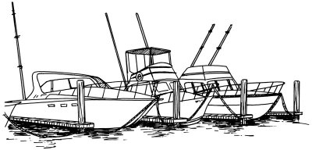

In this section, we'll show you how to draw this harbour scene landscape. You can draw it freehand while looking at your computer monitor, or you can print out this page to get a closer look at each step.

Here, we'll show you an illustration of each step and then give you a description of how to draw it. Follow the red lines in each illustration to learn exactly what to draw in that step. The lines drawn in previous steps are shown in gray.

To start the harbour scene landscape, draw three long, narrow shapes with a pointed end on the right side.



Step 1: Begin this scene in the upper centre of the drawing area. For the boats, draw three long, narrow shapes with a pointed end, or bow, on the right side. Make them with nearly straight lines for the tops and curved lines for the bottoms.

Draw the pointed end of the fourth boat on the left. To place the piers between boats, first draw small but long rectangles near the hulls as shown. These will be the ends of the piers. Draw three straight lines back to the left that come together slightly (it may help to practice drawing these pier shapes on a separate piece of paper).

To draw the harbour scene landscape, put in the vertical posts at the ends of the piers with straight lines.

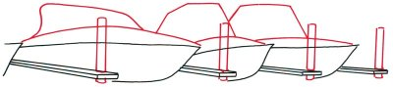

Step 2: Put in the vertical posts at the ends of the piers with straight lines. Make the post tops and bottoms slightly rounded. Create the top surfaces of the boats, or decks, with long curves running from the tip of the bow. Draw the two cabins on the right with more straight lines. Carefully sketch curved lines on the boat on the left.

To draw the harbour scene landscape, add details to the boat cabins with straight and slightly curved lines.

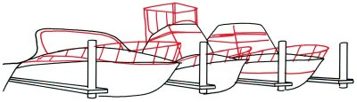

Step 3: Form the guard rails on the front of the decks with two intersecting curved lines. Draw the vertical rail supports with a series of angled straight lines that are parallel to one another and evenly spaced. Add details to the cabins with straight and slightly curved lines. Place a boxlike shape above the cabin of the boat in the centre. Use a wide, upside down, U-shaped line for the upper part of the boat on the left.

To draw the harbour scene landscape, add detail to three boat antennas with short horizontal lines.

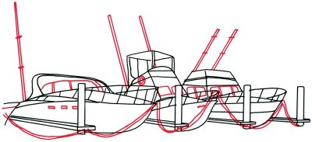

Step 4: Attach four heavy ropes to the bows of the boats with pairs of curved lines. Draw one or two tall poles or radio antennas on each boat. Use thin lines made with a ruler. Add detail to three antennas with short horizontal lines. Make windows and portholes on the cabins with slanted rectangles. Draw a round life preserver on the side of one of the boat cabins using a circle within a circle.

To finish your harbour scene landscape, add texture to the ropes with short, diagonal lines.

Step 5: Carefully shade around the bottoms of the boats with a back-and-forth movement of your pencil. Outline individual planks on the piers by adding short, straight lines, spaced closely together on the sides. Put straight and curved lines on the posts for texture. Shade the underside of the cabin's roof with diagonal lines. Add texture to the ropes with short, diagonal lines.

How to Draw Pirate Ships
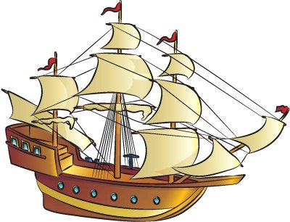
Ahoy, mateys! Use the easy instructions on this page to draw your own pirate ship, in the Caribbean or elsewhere.

Follow the red lines in each illustration to learn exactly what to draw in that step. The lines drawn in previous steps are shown in gray. Here, we'll show you an illustration of each step and then give you a description of how to draw it.

How to Draw Pirate Ships: Draw the body of the pirate ship.

Step 1: Draw the long, triangular main form for the boat.
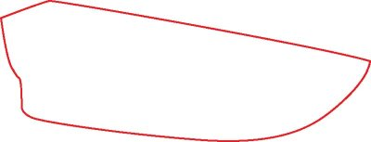
How to Draw Pirate Ships: Add details to the deck of the boat.

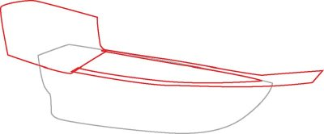
Step 2: Add an angled shape on the back end of the boat. Draw a line along the side of the boat, and continue it on to form a post coming off the front end of the ship. Bring the line back along the far side of the hull.

How to Draw Pirate Ships: Outline the top structures to add depth.
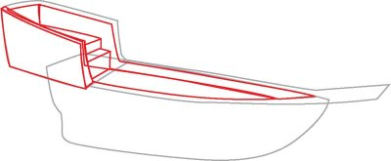

Step 3: Outline the back shape and the top of the boat's hull to add depth and create the ship's deck. Use stacked rectangles to add details to the back deck and deck steps.

How to Draw Pirate Ships: Draw three tall masts.

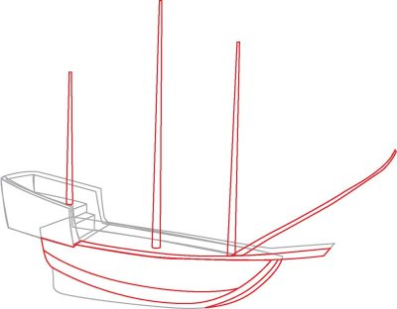
Step 4: Draw three tall masts rising from the deck. Add a fourth mast angling forward from the deck. Draw a long, curved bar that extends to the end of the post on the boat's tip. Use lines to sketch some side beam details on the hull.

How to Draw Pirate Ships: Add crossbars to the masts and portholes to the side of the ship.

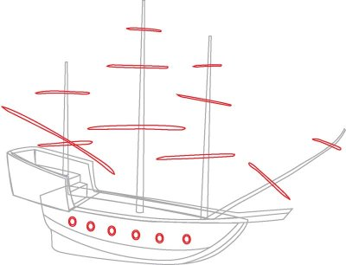
Step 5: Sketch long, thin sticks on the masts to create the crossbars. Add six circular porthole windows on the boat's side.

How to Draw Pirate Ships: Add flags to the masts and details to the ship.

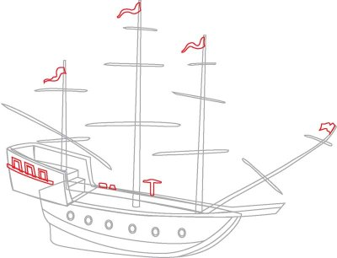
Step 6: Draw three rectangular windows on the back of the ship. Add a long, thin rectangle underneath them to create detail. Sketch flags on each mast. Draw two small wedges and a shape like a pickaxe on the far side of the deck.

How to Draw Pirate Ships: Draw sails.

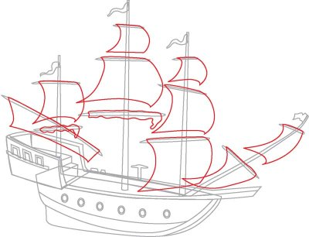
Step 7: Draw sails using the crossbars and masts as guides. The lowest sails on the back two masts are rolled up on the crossbars. To create this look, draw a squiggly-lined rectangular shape.

How to Draw Pirate Ships: Add lines between the sails.

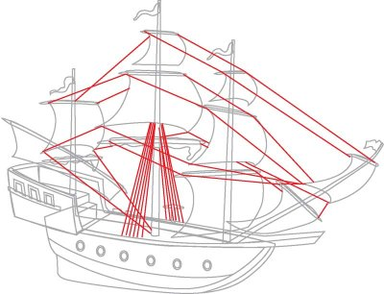
Step 8: Draw lines going from one crossbar to another. Add several lines angling down from the centre mast.

How to Draw Pirate Ships: Trace the final drawing with a felt-tip pen.

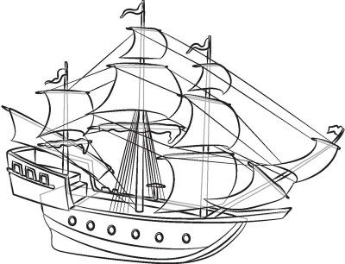
Step 9: Trace the pencil lines you want to keep with a felt-tip pen. Erase any extra lines.

Draw a day at the lake with water skiing or maybe a swift race around an aquatic track with our next drawing project.

How to Draw Sailboats
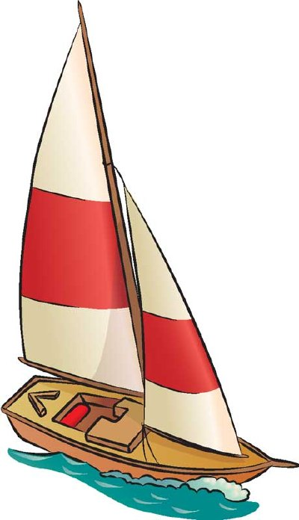

Sailboats travel far and wide, exploring the ocean and seeking out tropical locales. Use our step-by-step instructions to create your own sailboat scenes.

In this section, we'll show you how to draw the above sailboat.

Follow the red lines in each illustration to learn exactly what to draw in that step.

The lines drawn in previous steps are shown in gray. Here, we'll show you an illustration of each step and then give you a description of how to draw it.

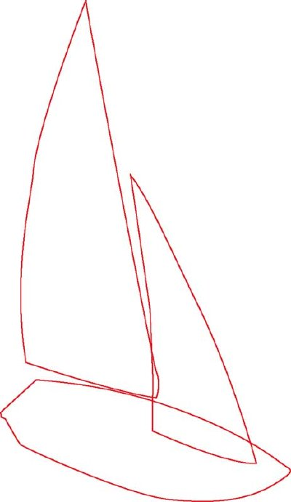
Draw the body and sail of the sailboat.

Step 1: Start the sailboat with two big curved triangles for the sails. Add a pointed shape for the hull.

How to Draw Sailboats: Add a seating area to the sailboat.

Step 2: Draw a curved line to form the side of the hull. Sketch a rectangle with a rounded end for the seating area. Add a fat bracket shape on top of it.

How to Draw Sailboats: Add the mast to the sailboat.

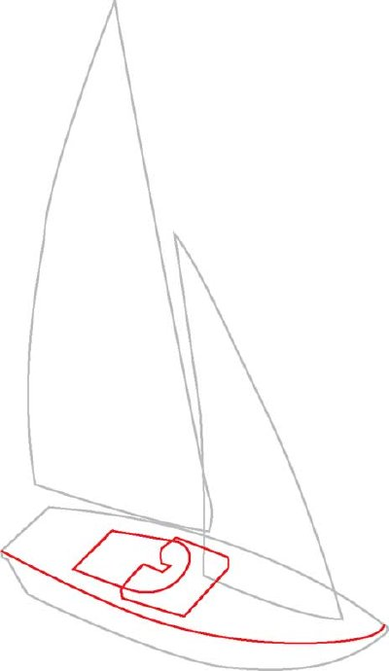
Step 3: Draw the mast between the sails. Add edge lines following the hull. Sketch a V-shape bar to create deck detail, and add lines for depth in the seating area. Draw a small post on the front of the boat.

Add details to the sails and seating area.

Step 4: Add rectangular crossbars at the bottom of both sails. Draw detail lines on the V shape and in the seating space. Add detail lines to each sail.
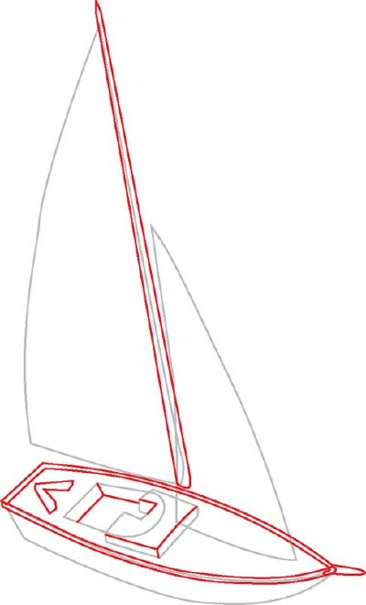

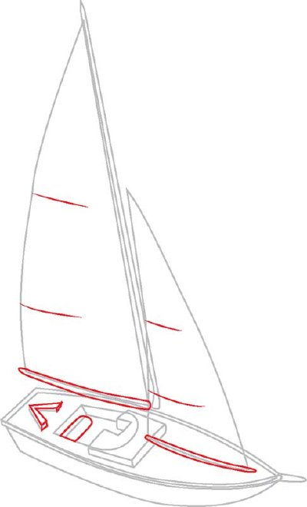

Draw wavy lines for water.

Step 5: Draw wavy lines under the boat for the water.

Trace the final drawing with a felt-tip pen.

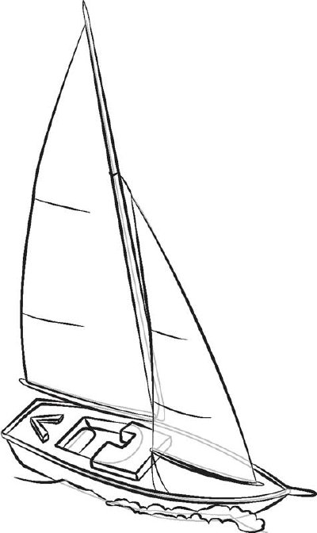
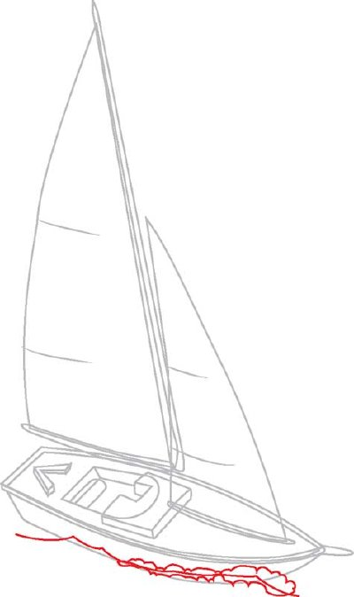

Step 6: Use a felt-tip pen to trace the lines you want to keep. Erase any extra pencil lines.

How to Draw a Country Church

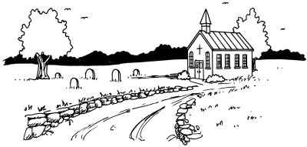

This country church lies at the end of a stone-lined path surrounded by lush trees. You’ll have a great time learning to draw all the components of this charming landscape.

In this section, we'll show you how to draw this country church landscape. You can draw it freehand while looking at your computer monitor, or you can print out this page to get a closer look at each step.

Here, we'll show you an illustration of each step and then give you a description of how to draw it. Follow the red lines in each illustration to learn exactly what to draw in that step. The lines drawn in previous steps are shown in gray.

To start your country church landscape drawing, sketch a light horizontal line for the horizon.

Step 1: Sketch a light horizontal line for the horizon. Place it in about the middle of your drawing area. Make a closed rectangle for the long side of the church building. Add an three-sided rectangle that is open at the top for the front. Make all vertical lines parallel.

Use a slanted rectangle for the visible side of the roof. Connect the top of the roof to the top of the slanted line on the left to complete the outline. Indicate the beginning of a road with two curving lines that come together near the side of the church building.

To draw this country church landscape, use rectangles with half-circles at the top for the front windows.

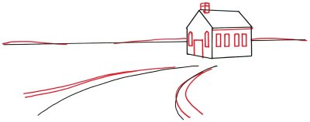

Step 2: Add a few gentle curves to the horizon line. Begin the windows, the door, and the steeple on the church with rectangles. Use rectangles with half-circles at the top for the front windows. Add a second set of lines along the roadway as the beginning of a stone wall.

To draw this country church scene, place a couple of trees in the landscape for depth.

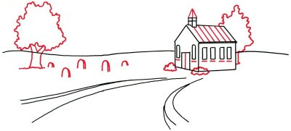
Step 3: Place a couple of trees in the landscape for depth. Use a thick trunk that changes to two large main branches for the first tree. Top both trees with an oval of leaves, made with squiggly lines. Add five or six upside down U-shapes as gravestones. Give depth to each of them by adding a curved line on the right side.

Begin adding details to the church. Finish the steeple with two side-by-side, upside-down V shapes. Evenly space six lines on the roof, parallel to the lines already there. Use squiggly lines in the shape of flattened ovals for shrubs in front. Put short horizontal lines under each window and a vertical line down the centre of the doorway.

To draw a country church landscape, add a tree line in the distance to provide depth.

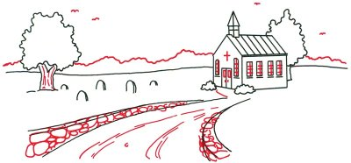

Step 4: Outline individual stones in the walls along the road with irregular ovals of different sizes. Use mostly vertical lines on the sides of the trees to give them the look of bark. Add a tree line in the distance to provide depth.

Draw some birds in the sky with pairs of short rounded lines. Put in a series of long curving lines for ruts in the road. Complete the church with small rectangles on the door, short vertical lines for handles, and straight intersecting lines for the windows. Make a cross above the door.

To finish the country church landscape, lightly shade part of the surface of the stones in the wall.

Step 5: Use dark shading for the trees in the background. Create a shadow at the side of the church with a series of crooked horizontal lines. Add clumps of grass around the gravestones and tree with short, straight lines, spaced closely together.

Scatter spiked, jagged shapes as tufts of grass on the sides of the road and in random spots in the surrounding fields. Form sills beneath each window by adding short vertical lines to finish the long rectangles, which are slightly wider than the windows themselves. With diagonal lines, lightly shade part of the surface of the stones in the wall.

Your landscape drawing is finished! Even if you don't get it right the first time, keep practicing until you're happy with your drawing. The village scene in the next section includes it all -- a small church, house, and even a barn. Keep reading to learn how to draw this landscape in just five steps.

How to Draw a Cityscape
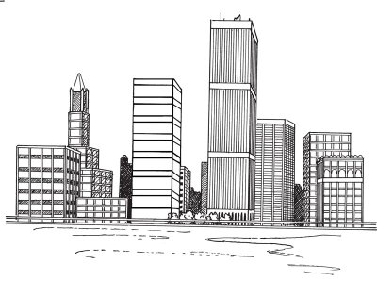

The city has its own brand of amazing landscapes, like this dazzling, towering skyline. This landscape is a great drawing project for city and country lovers alike.

In this section, we'll show you how to draw this cityscape. You can draw it freehand while looking at your computer monitor, or you can print out this page to get a closer look at each step.

Here, we'll show you an illustration of each step and then give you a description of how to draw it. Follow the red lines in each illustration to learn exactly what to draw in that step. The lines drawn in previous steps are shown in gray.

To start drawing the cityscape landscape, sketch a horizontal line below the centre of the drawing area.



Step 1: Sketch four horizontal lines below the centre of the drawing area. Using a ruler, add a number of rectangles of different sizes, as shown, some overlapping others. These shapes are the front surfaces of the buildings. All vertical lines should be parallel.

To draw the cityscape landscape, place a building in the left part of the background with a tall, narrow shape.

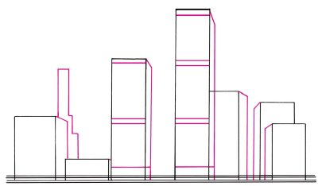

Step 2: Add a second side to each building to convey a sense of depth. Do this by drawing a vertical line shorter than the two lines for the front of the building.

Connect the sideline to the front with a diagonal line. Then lay down evenly spaced horizontal lines on the front surfaces of the two buildings near the middle of the scene. Place another building in the left part of the background with a tall, narrow shape that has steps on one side.

To draw the cityscape landscape, evenly space pairs of vertical lines on the sides of some of the buildings.

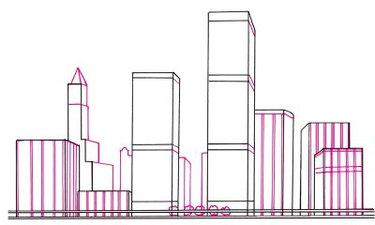

Step 3: Sketch five trees in front of the middle buildings using squiggly half circles around the top railing. Evenly space pairs of vertical lines on the sides of some of the buildings, as shown.

Use diagonal lines on the sides of the two tall middle buildings to continue the bands. Draw a few more buildings in the background. Give the tall narrow building on the left a second side using parallel lines connected to the front with diagonal lines. Complete the roof using two triangles.

To draw the cityscape landscape, draw intersecting horizontal and vertical lines on the sides of the buildings for windows.

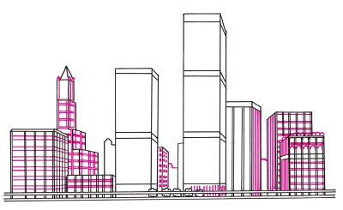
Step 4: Draw intersecting horizontal and vertical lines on the sides of the buildings for windows. Sketch columns on the corners of the tall building at left using vertical lines with an inverted V shape on top.

Use half circles for arches on the roof of the building at the far right. With more half circles, make the tops of the upper windows. Use dark squares for the windows of the smaller building in the middle, and form the outlines of more buildings in the distance. Draw vertical lines around the base of the tallest building.

To finish drawing the cityscape landscape, sketch curving lines in the foreground to make it look like a watery surface.

Step 5: Thicken the lines at the bottom of the tallest building and give them rounded tops. Put vertical lines between the bands of the tallest building. Darken the buildings at the back.

Place horizontal lines on the tall buildings at the right and left of the tallest building. Shade the sides of some buildings using diagonal lines. Add short, curved lines to the trees. Sketch curving lines in the foreground to make it look like a watery surface.

How to draw a bulldozer.
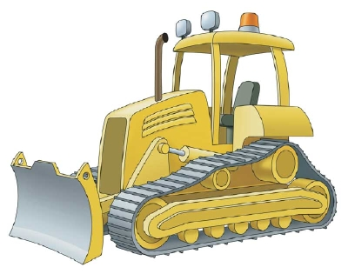

You can draw this construction vehicle freehand while looking at your computer monitor or print out this page to get a closer look at each step.

Follow the red lines in each illustration to learn exactly what to draw in that step. The lines drawn in previous steps are shown in gray. Here, we'll show you an illustration of each step and then give you a description of how to draw it.

To draw a bulldozer, start by drawing the wheels that run the track.

Step 1: To make the wheels that run the track, draw five small circles on the bottom; add outlines to provide depth. On each side of the five circles, draw a ring.
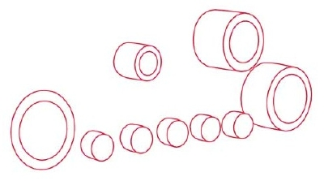
Attach a curved rectangle to the side of the furthest ring to add depth. Above the circles, draw two more rings; add curved rectangles to these as well.
When drawing a bulldozer track, add a curved rectangular shape over the bottom wheels.

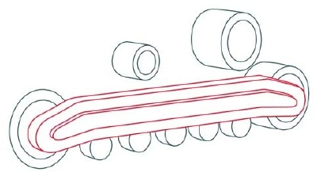
Step 2: Draw a curved rectangular shape over the bottom wheels; notice how the shape dips down at both ends. Draw a similar, smaller shape inside the first. Add outlines to provide depth.
When drawing a bulldozer track, create lines around the circles of the track and inside of the track.

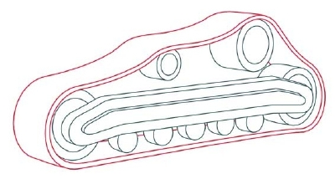
Step 3: Draw a line around all the circles; make another line just outside the first. Draw the outside line to make the side edge and face of the track. Also notice the small lines you need to make on the inside of the track.
To draw a bulldozer, you must add a blade.
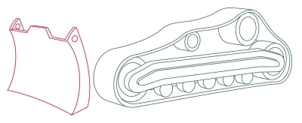

Step 4: To make the blade, draw a curved rectangular shape; add a tab to the top middle of the rectangle. Draw the sides of the blade and the details as shown.
When drawing a bulldozer, draw the lift arm that connects the blade to the bulldozer, and the fender.
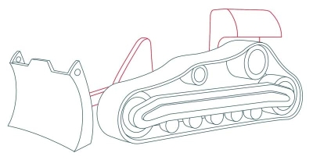

Step 5: Draw the rounded triangle and rectangle that make up the lift arm that connects the blade to the bulldozer; add outlines for depth. Draw the fender -- follow the example shown.
When drawing an excavator, draw the hood and the grille.

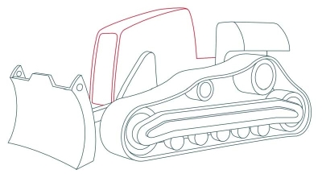
Step 6: For the hood, make a rounded square shape with a tab at the fender. Draw outlines where shown. On the front of the hood, draw the grille, which is a rectangle with the top edges rounded.
To draw a bulldozer cab, draw four thin, slightly curved bars.

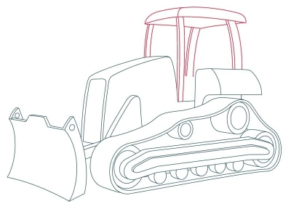
Step 7: To make the cab, draw four thin, slightly curved bars. Outline each for depth. Draw the roof as shown.
When drawing a bulldozer, add a driver's seat, headlights, a safety light, and an exhaust pipe.

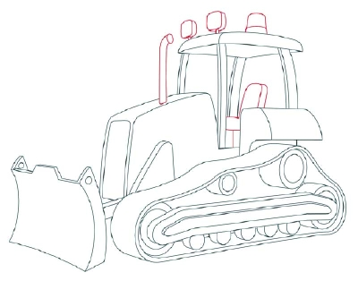
Step 8: Draw the driver's seat in the cab, and add two headlights and a safety light on top of the roof. On the hood, draw a curved exhaust pipe. Add a circle to the end of the pipe.
When drawing the final body parts of the bulldozer, draw vents and a hydraulic cylinder.

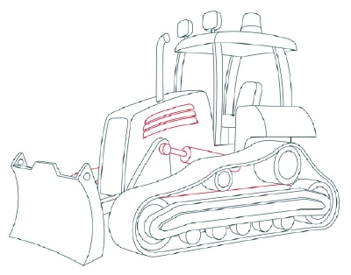
Step 9: Draw three rectangular vents in the hood. Each vent is a little larger than the one above it.

Draw a hydraulic cylinder extending from the triangular part of the lift arm to below the fender. Look carefully, and draw the other lines that finish the body of the dozer.
When drawing a bulldozer, use a ruler to draw cleats on the tread faces.

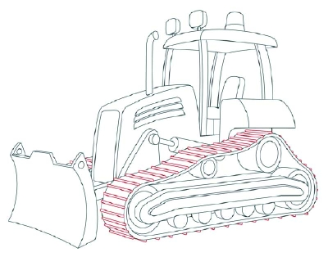
Step 10: To make cleats on the tread faces, use a ruler to draw the small evenly spaced rectangles across the track. On the back and underside of the tread, draw small triangular bumps.
When finished drawing the bulldozer, trace the permanent lines with a felt-tip pen, and erase pencil lines.

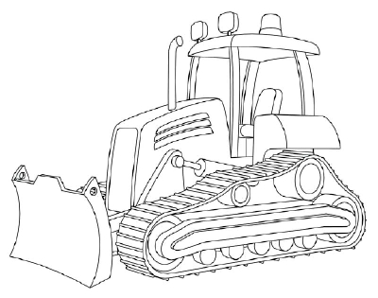
Step 11: Use a felt-tip pen to trace over the lines you want to keep, and erase the extra pencil lines.

You did it! So let's move on to a construction vehicle that does a lot more than push materials around. It lowers, lifts, and moves heavy materials high into the sky, and in any direction they need to go.

How to Draw a Field of Flowers

Several elements of nature combine to create this lovely landscape scene -- sun and clouds, trees, stone, and a field of flowers. This landscape will give you a great chance to practice drawing a variety of flowers.

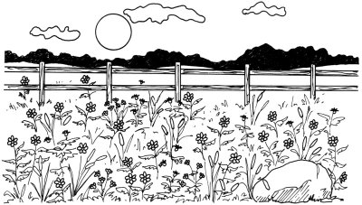

In this section, we'll show you how to draw this field of flowers landscape. You can draw it freehand while looking at your computer monitor, or you can print out this page to get a closer look at each step.

Here, we'll show you an illustration of each step and then give you a description of how to draw it. Follow the red lines in each illustration to learn exactly what to draw in that step. The lines drawn in previous steps are shown in gray.

To start drawing the field of flowers landscape, place a line above the middle for the horizon.


Step 1: Place a line above the middle of the drawing area for the horizon. Sketch a large, oblong oval shape to outline a boulder in the foreground on the right side. Draw a smaller oval near it for a stone. Make many tiny circles scattered at random beneath the horizon line. These will be the centres of flowers. Add many small, narrow ovals, pointing mostly up and down.

To draw the field of flowers landscape, change the horizon line to one that is slightly wavy.

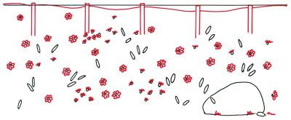
Step 2: Change the horizon line to one that is slightly wavy. Using a ruler as a guide to level the tops, draw five narrow open rectangles for fence posts. Space them equally. Add a few blades of grass near the boulder with short jagged lines. To form flowers, draw six or seven round petals on about half the tiny circles. Do the same, using fewer petals in a somewhat different shape, for the remainder of the circles.

To draw the field of flowers landscape, add stems to flowers with straight or slightly curving lines.
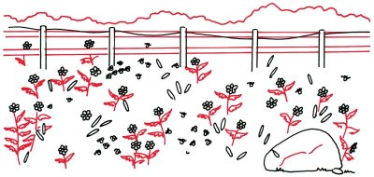

Step 3: Add stems to some of the flowers with straight or slightly curving lines. Draw leaves, using a curving line on top and a jagged line below. Give shape to the boulder with broken line. Attach rails to the fence posts with the help of a ruler. Remember to keep the upper and lower rails the same width. Above the fencepost, sketch in a wavy tree line.

To draw the field of flowers landscape, put stems on the remaining flowers with slightly curved lines.

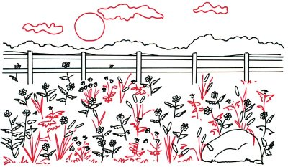
Step 4: Trace around a coin to form a round sun in the background. Add three irregular shapes with curved but not jagged lines for clouds. Put stems on the remaining flowers with slightly curved lines. Draw long, narrow leaves for the oval-shaped flowers. Use squiggly lines for the remaining leaves. Make shapes like an upside-down V for tall and short tufts of grass.

To finish your field of flowers landscape, fill in between the flowers with short, squiggly lines for grass.

Step 5: Fill in between the flowers with short, squiggly lines for grass. Draw long lines in the fence posts and rails for texture. Darken the tree line as shown. Shade the boulder with diagonal lines.

How to Draw a Rural Lane
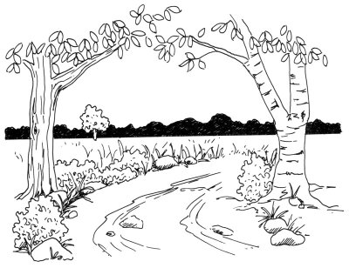

With a forest silhouette in the background and a canopy of trees in the foreground, this rural lane is a peaceful nature scene. This landscape is a wonderful drawing challenge for nature lovers.

In this section, we'll show you how to draw this rural lane landscape. You can draw it freehand while looking at your computer monitor, or you can print out this page to get a closer look at each step.

Here, we'll show you an illustration of each step and then give you a description of how to draw it. Follow the red lines in each illustration to learn exactly what to draw in that step. The lines drawn in previous steps are shown in gray.

To start drawing a rural lane landscape, draw a horizon line just above the centre of the page.

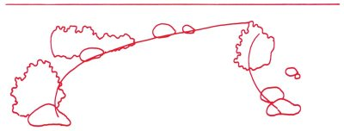
Step 1: Lightly draw a horizon line just above the centre of the page. Rough in two long, curving lines that come together somewhat for the outline of the road. Draw a few large ovals for rocks, placing them randomly along the sides of the road. Make three bushes with squiggly lines to define the roadway and distinguish it from the surrounding fields.

To draw a rural lane landscape, sketch a tree and branches on the left, with a tall main trunk.
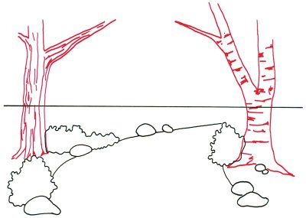

Step 2: Sketch a tree and branches on the left, with a tall main trunk. Show the bark on the side of the trunk with long up-and-down lines. Use short horizontal lines for the tree on the right, a birch, which has a smaller main trunk. When filling in lines on the birch, notice that the lines are roughly horizontal, not vertical like the other tree.

To draw a rural lane scene, sketch several irregular oblong shapes on the road to look like rocks and stones.

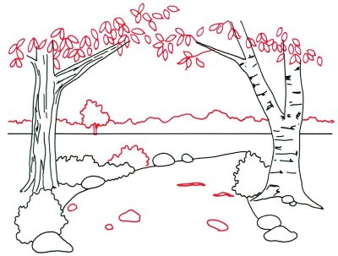
Step 3: Draw a squiggly line across the page, just above the horizon line, to indicate the tops of distant trees. Add smaller branches to the trees with a few crooked lines. Arrange dozens of leaves in random clumps by sketching shapes like teardrops. Place one more tree in the background and another bush by the roadway with squiggly, circular lines. Sketch several irregular oblong shapes on the road to look like rocks and stones.

To draw a rural lane landscape, make roughly parallel lines to look like ruts on the surface of the roadway.
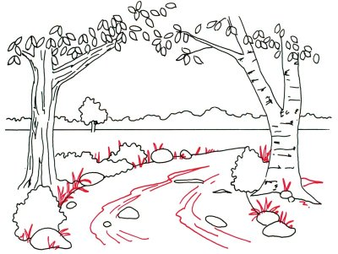

Step 4: Make a series of roughly parallel lines to look like ruts on the surface of the roadway. Sketch several clumps of tall grass at the edge of the road and around the bushes. Shape them like spikes: mostly upright, but a few are bent over.

To finish your rural lane drawing, lightly shade the rocks

Step 5: Heavily shade the area between the horizon and the top of the tree line. Add short, squiggly lines to the distant tree. Use the same method for the bushes along the roadway. Sketch a few very short lines to look like tufts of grass in the field. As the last step, lightly shade the rocks.

Your landscape drawing is finished! Even if you don't get it right the first time, keep practicing until you're happy with your drawing.

How to Draw a Mountain Stream
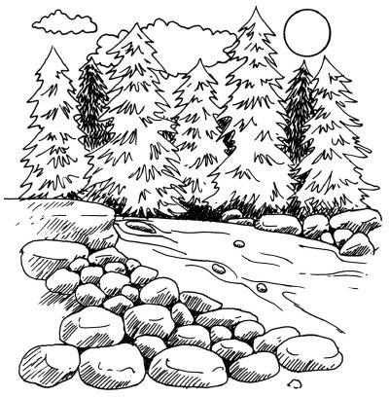
This stream sits high atop a mountain, surrounded by lush trees, boulders, and sunshine. This landscape drawing is a great opportunity to practice attention to detail and perspective.

In this section, we'll show you how to draw this mountain stream landscape. You can draw it freehand while looking at your computer monitor, or you can print out this page to get a closer look at each step.

Here, we'll show you an illustration of each step and then give you a description of how to draw it. Follow the red lines in each illustration to learn exactly what to draw in that step. The lines drawn in previous steps are shown in gray.

To start drawing the mountain stream landscape, draw a horizontal line about halfway down the page.

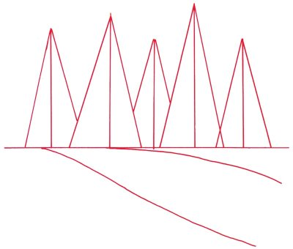

Step 1: About halfway down the page draws a horizontal line. Sketch the edges of the streambed with curving lines extending upward from right to left. For pine trees, sketch in a series of tall triangles that overlap one another. Lightly add a line from the top of each triangle down to the base horizontal line.

To draw the mountain stream landscape, carefully shape the outline of the pine trees with jagged lines of different lengths.

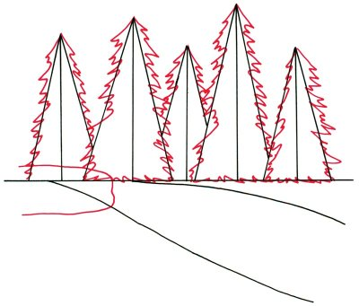

Step 2: Carefully shape the outline of the pine trees with jagged lines of different lengths. Maintain the sense of depth by showing some trees standing in front of others. Place a large, bumpy, oblong shape to form a boulder along the side of the stream.

To draw the mountain stream landscape, draw scalloped shapes for puffy clouds above the trees.

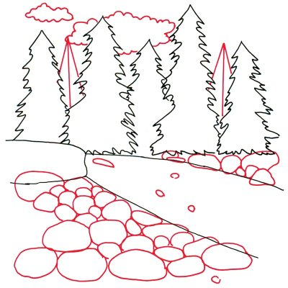

Step 3: Add more pine trees behind the ones you have already drawn by making triangles as before. Draw scalloped shapes for puffy clouds above the trees. Show rocks on both sides of the stream with irregular ovals. Put more rock shapes on the surface of the stream itself.

To draw the mountain stream landscape, show the contour of the boulders with slightly curving lines.

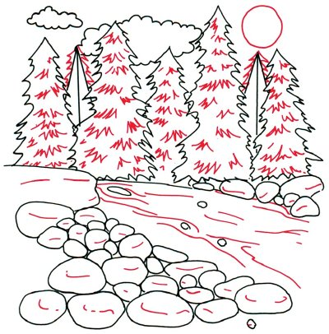

Step 4: Draw a circle for the sun. Shape the two trees in the rear with jagged lines. Add details to the pine trees with short jagged lines. Show the contour of the boulders with slightly curving lines. Put in more curving lines to show the surface of the water.

To finish the mountain stream landscape, add shape to the boulders by shading with diagonal lines.

Step 5: Darken the trees in the rear with many jagged lines. Shade the area under the trees with crisscross lines. Add shape to the boulders by shading with diagonal lines.

How to Draw a Mountain Vista
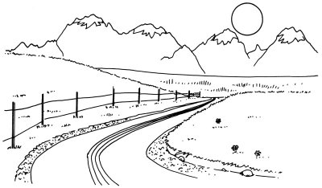

A paved road leads to a range of snow-capped mountains, gleaming in the sun, in this landscape. You can almost smell the crisp winter air when gazing at this scene.

In this section, we'll show you how to draw this mountain vista landscape. You can draw it freehand while looking at your computer monitor, or you can print out this page to get a closer look at each step.

Here, we'll show you an illustration of each step and then give you a description of how to draw it. Follow the red lines in each illustration to learn exactly what to draw in that step. The lines drawn in previous steps are shown in gray.

To draw the mountain vista landscape, lightly draw a line across the page for the horizon.


Step 1: Lightly draw a line across the page for the horizon. Place it about one-third of the way from the top. Add four curving lines, beginning from the lower centre of the page and running first to the left and then sharply to the right. Show that the road goes off into the distance by bringing the lines closer together at the top. This use of lines that come together to show depth is known as perspective.

To draw the mountain vista landscape, draw inverted V-shapes using jagged lines to show a distant range of mountains.

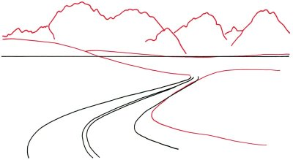
Step 2: Draw inverted V-shapes using jagged lines to show a distant range of mountains. Alter the horizon line with curved lines to look like gently rolling hills. Create another hill with a lazy curve to the right of the centre.

To draw the mountain vista landscape, add grass on the hillsides and near the road.

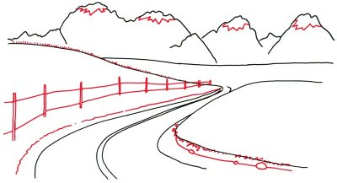
Step 3: Draw sharply jagged lines for snowcaps on the tops of the highest mountains. Add grass on the hillsides and near the road with many slanted and jagged lines. Make a series of narrow fence posts with double vertical lines, making them smaller as they fade off toward the end of the road. Use nearly straight lines to show fence rails. Sketch the edge of the road with squiggly lines. Draw rocks near the road with irregular ovals.

To draw the mountain vista landscape, sketch a circular sun in the sky.

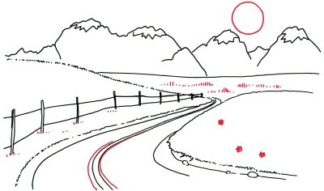
Step 4: Draw a circular sun in the sky, and then put in some tall grass in the middle distance with short lines. Use more short lines for clumps of low grass along the fence. Scatter a few daisy like flowers on the hillside. Add two more curved lines in the centre of the road.

To finish your mountain vista landscape, add further details to the shoulder area at the edge of the road.

Step 5: Finish this sketch by adding further details to the shoulder area at the edge of the road. Use plenty of dots and short, squiggly lines to look like rocks and gravel. Place more grass on the hills to the left and right sides using a mixture of short lines, straight and jagged.

Your landscape drawing is finished!

How to Draw an Icy Water Pump

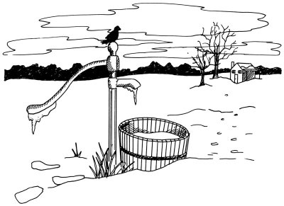
A country water pump has iced over in the winter chill in this landscape. Pay close attention to perspective when working on this drawing.

In this section, we'll show you how to draw this icy water pump landscape. You can draw it freehand while looking at your computer monitor, or you can print out this page to get a closer look at each step.

Here, we'll show you an illustration of each step and then give you a description of how to draw it. Follow the red lines in each illustration to learn exactly what to draw in that step. The lines drawn in previous steps are shown in gray.

To begin your icy water pump landscape, sketch a horizon line as the starting point.

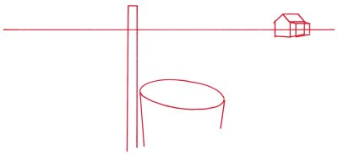
Step 1: Sketch a horizon line as the starting point. On the right side of the line, use a five-sided figure for the front wall of a house. Extend parallel lines backward from three points of the figure to form the side and roof. Attach a smaller boxlike shape to the side. In the foreground, outline a narrow post like shape, using parallel lines. This forms the beginning of the water pump. Make the top of a wooden barrel with a large oval. Hang straight lines down from the ends of the oval.

To draw the icy water pump landscape, change the horizon from a straight line to one that is slightly curved.

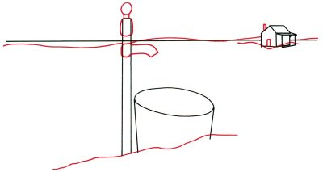

Step 2: For a mound of snow, extend a wavy line along the foreground below the pump and barrel. Change the horizon in the background from a straight line to one that is slightly curved. Sketch a small circle over a rounded rectangle for the top of the pump. Form a faucet with a long rectangle with a twist at one end. Use tiny rectangles to form the door and chimney on the house.

To draw an icy water pump landscape, form the pump handle with gently curving lines and a rounded end.
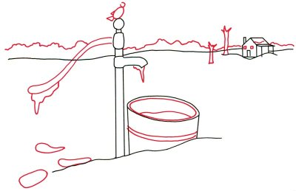

Step 3: Make footprints in the snow with some oblong shapes to the left of the pump. Give thickness to the barrel by drawing a second oval just inside the first one. Draw a curved double line for a band around the barrel. Use a curved line for snow inside the container. Form the pump handle with gently curving lines and a rounded end. Use jagged lines to form a clump of ice.

Add an icicle with a long pointed shape on the tip of the faucet, more jagged than on the handle. In the background, make a long wavy line to give the appearance of a mountain range. Sketch the trunks of two trees with jagged tops near the house. Add a curved line to the roof to give the appearance of snow. Place two windows on the house by drawing tiny squares. Add a combination of ovals and triangles to form the rough shape of a bird on the pump handle.

To draw the icy water pump landscape, sketch long, thin winter clouds to fill the sky.

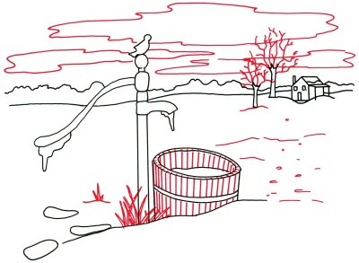
Step 4: Carefully add a great many closely spaced parallel lines to look like slats on the barrel. Draw some tall, spindly grass with pointed shafts that overlap one another. Fill in the space between the barrel and the house with some short lines, tiny ovals, and other odd shapes. Complete the branches at the tops of the two trees with a mixture of straight and jagged lines. Sketch long and thin winter clouds, with both gently and sharply curving lines, to fill the sky.

Use careful shading when finishing your icy water pump landscape.

Step 5: Finish the landscape with careful shading. The darkest shading blackens the bird and the space between the horizon line and the mountaintops. Add a cross to each of the windows for windowpanes. Draw a dot on the door for the doorknob. Use diagonal lines for lighter shading on the tree trunks, the side of the house, inside the water barrel, and on the pump itself.

Your landscape drawing is finished! Even if you don't get it right the first time, keep practicing until you're happy with your drawing. The delightful barn and pond landscape includes a peaceful pond, a rustic barn, and even a floating duck.

How to Draw a Waterfall

The centrepiece of this landscape is a majestic, rushing waterfall. Surrounded by stone and plants, this waterfall landscape promises a wonderful escape.

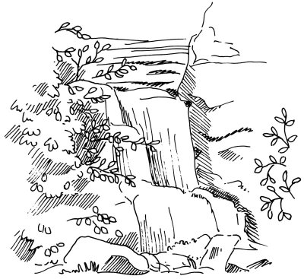In this section, we'll show you how to draw this waterfall landscape. You can draw it freehand while looking at your computer monitor, or you can print out this page to get a closer look at each step.

Here, we'll show you an illustration of each step and then give you a description of how to draw it. Follow the red lines in each illustration to learn exactly what to draw in that step. The lines drawn in previous steps are shown in gray.

To start the waterfall landscape, begin with a rough outline of the watery part of the scene.

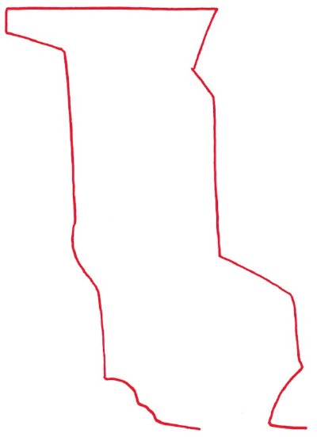

Step 1: Begin with a rough outline of the watery part of the scene. Form it like a long rectangle with an open, twisted bottom and a boxy, foot-like shape at the top. Use a few curving lines, but most of them should be straight.

When drawing the waterfall landscape, make tree branches with short, Y-shaped lines.

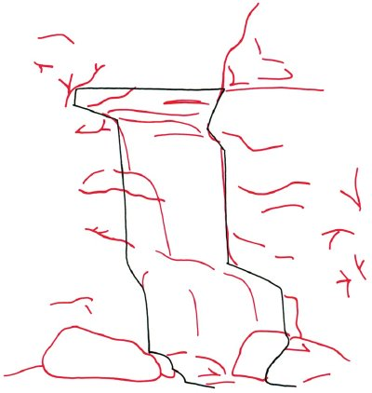

Step 2: Sketch two enormous boulders at the base of the waterfall with bumpy, oblong shapes. Suggest the movement of water over the falls with gently downward-curving lines. Use curving horizontal lines to indicate the contours of the cliff surrounding the falls. Make tree branches with short, Y-shaped lines.

When drawing the waterfall landscape, make jagged lines to look like grass near the bottom.

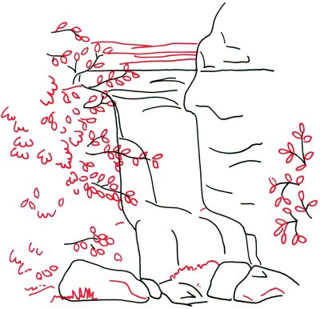

Step 3: Add teardrop shapes along the branches for leaves on both sides of the water. Use short, scalloped lines to show clumps of leaves. Make jagged lines to look like grass near the bottom. Create the impression of turbulent water at the base of the falls with some squiggly lines. Provide background and a sense of distance with more horizontal lines at the top.

To finish the waterfall landscape, add depth by shading with patterns of diagonal lines alongside the water.

Step 4: Sketch a series of long vertical lines in the water area to add to the appearance of falling water. Add depth by shading with patterns of diagonal lines alongside the water. Complete the landscape with additional shading in the upper water area, around the leaves, and on the boulders at the bottom.

How to Draw a Woodland Trail
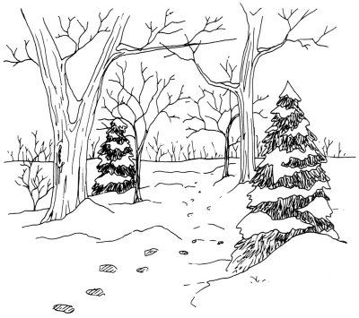
This landscape is right out of a holiday story. Pine trees frosted with snow, trees made bare by the winter chill -- even fresh footsteps in the snow.

In this section, we'll show you how to draw this woodland trail landscape. You can draw it freehand while looking at your computer monitor, or you can print out this page to get a closer look at each step.

Here, we'll show you an illustration of each step and then give you a description of how to draw it. Follow the red lines in each illustration to learn exactly what to draw in that step. The lines drawn in previous steps are shown in gray.

To start the woodland trail landscape drawing, sketch a line across the middle of the page as the horizon.

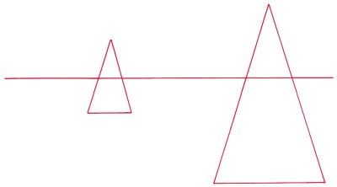
Step 1: Draw a single line across the middle of the page as the rough horizon. To show the position of the pine trees, construct two tall triangles, a large triangle on the right and a smaller one on the left.

To draw the woodland trail landscape, sketch the outline of a tall tree trunk.

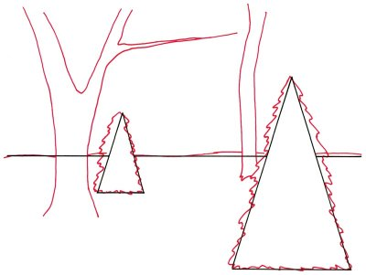

Step 2: Sketch the outline of a tall tree trunk to the left of the smaller triangle. Wake it wider at the base and narrow it slightly up to the main fork. Then it tapers much more. Put a second trunk on the right side, narrower than the first one. Alter the horizon slightly by adding a few very gentle curves. Use jagged lines to show the profile of the trees.

To draw the woodland trail landscape, add curved lines under and beside the trees to look like snow drifts.

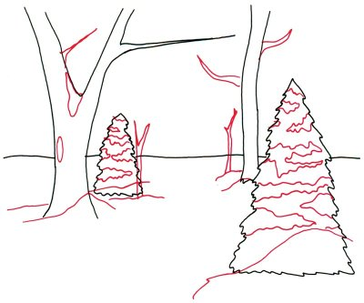

Step 3: Outline two more trunks for smaller trees in the middle area, between the existing trees. Add some heavy, pointed branches to the larger tree trunks. Form layers of snow on the pine trees by drawing angular shapes with squiggly lines. On the main fork of the larger tree, draw a patch of snow with a rounded triangle. Then sketch a long, narrow oval on the trunk of the tree. Add curved lines under and beside the trees to look like snow drifts.

Add a bark like texture to the trees in the woodland trail landscape with long, straight lines.

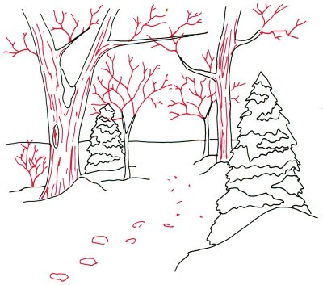

Step 4: Extend existing large branches with smaller ones made with single, jagged lines. Off to the left side, draw a bush with angular lines. Add a bark like texture to the trees with a series of long, mostly straight lines. Make footsteps in the snow with a string of very rough oblong shapes that look smaller as they disappear into the distance.

To finish the woodland trail landscape, draw a number of bare trees on the horizon with sketchy, angular lines.

Step 5: Draw a number of bare trees on the horizon with sketchy, angular lines. Lightly shade in the footsteps with diagonal lines. Add many scribble like lines on the sides of the pine trees. These lines should be nearly vertical in the middle area of the pine trees but point toward the outer ends of the branches at the sides. Finally, add a few light, angular lines to show drifts of snow.

How to Draw a Barn and Pond
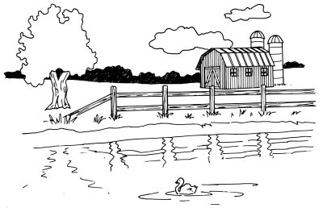
This farm life scene even includes an adorable duck, floating happily upon a pond. This landscape scene has a good variety of elements to draw -- water, building, plants, and animals.

In this section, we'll show you how to draw this barn and pond landscape. You can draw it freehand while looking at your computer monitor, or you can print out this page to get a closer look at each step.

Here, we'll show you an illustration of each step and then give you a description of how to draw it. Follow the red lines in each illustration to learn exactly what to draw in that step. The lines drawn in previous steps are shown in gray.

To start your barn and pond landscape drawing, lightly sketch a horizon line across the middle of the page.

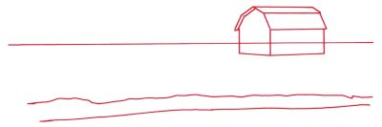
Step 1: Lightly sketch a horizon line across the middle of the page. Start the outline of the barn with a rectangle for the long side, and then add the front as a rectangle that is open at the top. All the vertical lines should be parallel. Connect two of the vertical lines with two angled lines, as shown.

Use slanted rectangles for the roof. Begin the edge of the lake with a nearly straight line to show the edge of the water. Draw another, irregular line above it to show the limit of the sandy area.

To draw the barn and pond landscape, draw rectangles for windows and a door.

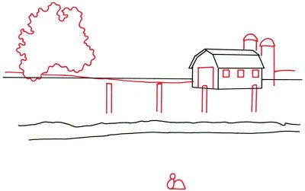
Step 2: Alter the horizon line so that it dips down in front of the barn and rises up behind it. Begin defining the barn by putting in rectangles for windows and a large door. Frame twin silo towers with tall rectangles, and cap them with half circles.

Start a tree to the left by sketching in the leafy top with a squiggly line. Draw fence posts with narrow open rectangles. Line up the tops of the posts with a ruler. Combine a small circle with an oval and a half circle to make the outline of a duck in the pond.

To draw the barn and pond scene, use V-shaped, horizontal, and vertical lines for boards on the barn door.

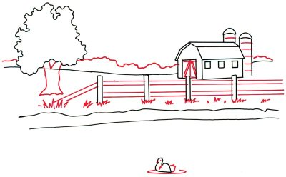
Step 3: Add a dot for the duck's eye, a tiny V-shaped figure for a beak, and a fluffy tail to make the duck look more real. Form a thin oval around it for a circular wave. Attach the rails between the posts by drawing horizontal and diagonal lines with the help of a ruler. Use a combination of V-shaped and horizontal and vertical lines for boards on the barn door.

Show sections in the silo with curved lines. Sketch the tree trunk using wavy lines. Use a squiggly line to form the top of the tree line in the background. Add tufts of grass along the edge of the pond with a series of jagged lines.

To draw the barn and pond landscape, give texture to the barn door with vertical lines.

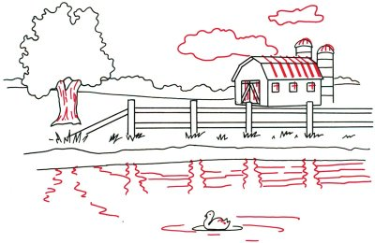
Step 4: Add clouds in the sky above the barn with irregular shapes. Give texture to the barn door with vertical lines. For the barn roof, use angled lines that follow the shape of the roof. Put crosses in the windows for windowpanes. Finish the top of the silo with four curved lines. Give texture to the tree trunk with broken lines. Show the reflections of the tree and fence on the water with wavy lines. Add a few feathers to the duck with tiny hooked lines.

Finish your barn and pond landscape with light shading to give texture to the fence.


Step 5: Darken the tree line in the background. Give the barn the look of wood siding with many closely spaced, parallel lines. Shade under the barn roof with crisscross lines. Finish with light shading to give texture to the fence.

